Click here for Setup "Open with Google Drive" - Operator Manual

Overview
There are two types of integrations we need to make with Google Drive:
- Integrate to Google Drive File Browser.
We’ll call it “Google Drive Menu Integration”
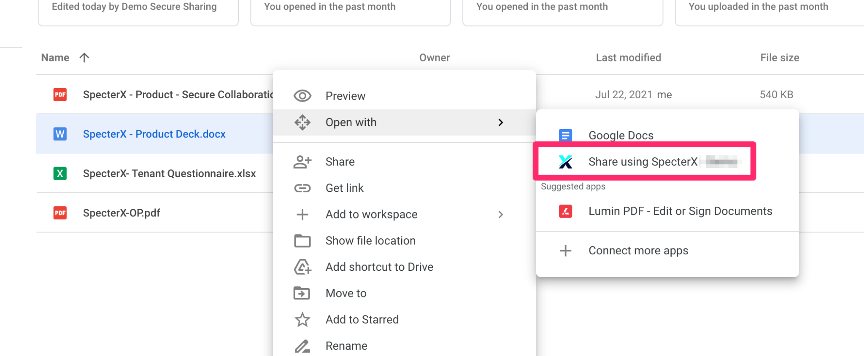
- Intercept the ‘Share’ button in Google documents opened through SpecterX.
We’ll call it “Google Docs Button Integration”
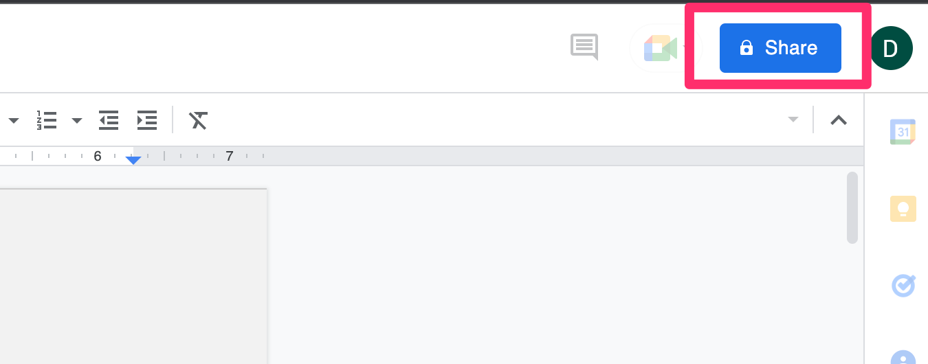

These are two very different integrations. One requires us to set up an application on our mediation tenant with permissions to the customer’s Google tenant. The other operates solely on our tenant, monitoring Gmail for email notifications generated as a side-effect of user actions.
More information in each of these in their respective manuals.

Table of contents
Overview
Google Drive Menu Integration - Manual
Create Google Application
Enable Google Drive API
Drive UI Integration
OAuth Consent
Credentials
Note
Testing
Google Docs Button Integration - Manual
Google Developer console
Create a new project
Create a topic
Create subscription
Create a service account
Create OAuth consent
Create OAuth 2.0 Client ID
GSuite
Add service account scopes
Create GSuite user
Repositories
common_modules
Update configuration repo

Google Drive Menu Integration - Manual

Create Google Application
- Go to https://console.cloud.google.com/apis/dashboard
- Click on the name of the currently open project
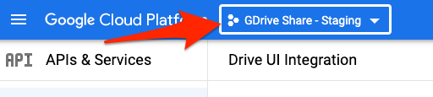
- In the popup that opens, click ‘New Project’
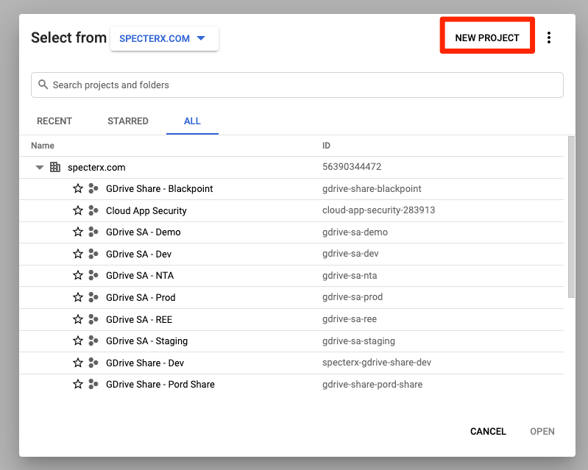
- Give the project name “GDrive Share - [tenant name]”.
Set the other two values (‘organization’ and ‘location’) to “specterx.com”
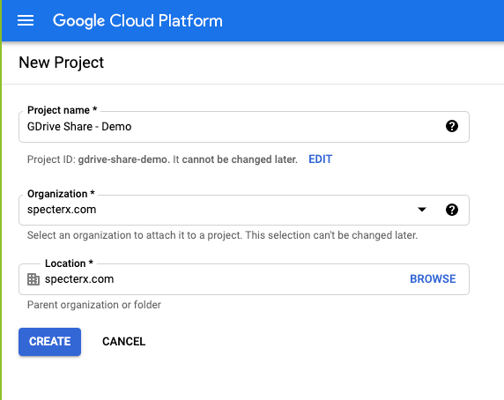

Enable Google Drive API
- After creating the project, make sure it is selected from the dropdown menu

- From the leftside menu, choose “Library”
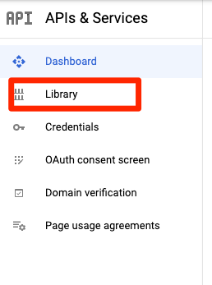
- In the search bar, type in “Google Drive API”. You should see it in the results. Click it.
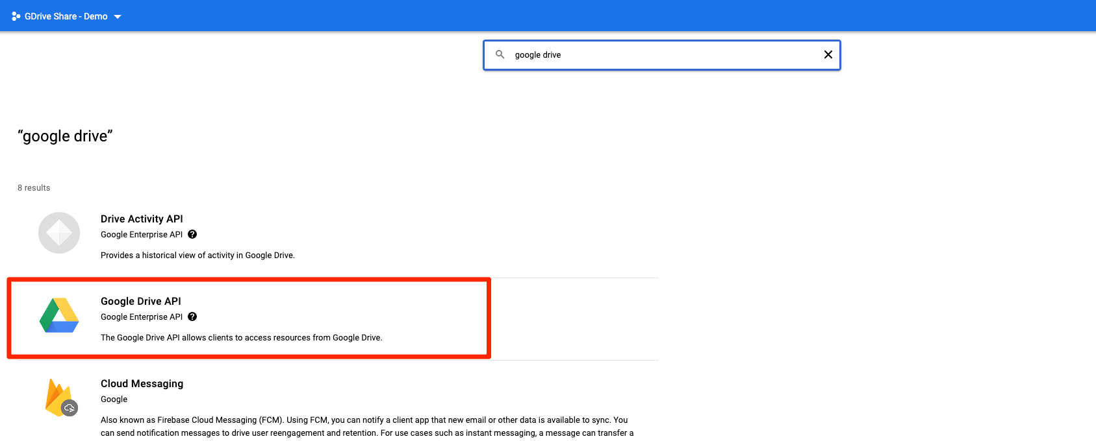
- Click “ENABLE” in the next screen.
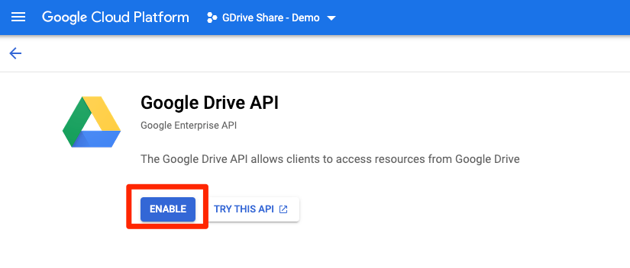

Drive UI Integration
- After enabling the Google Drive API, click “Manage” from the Google Drive API screen
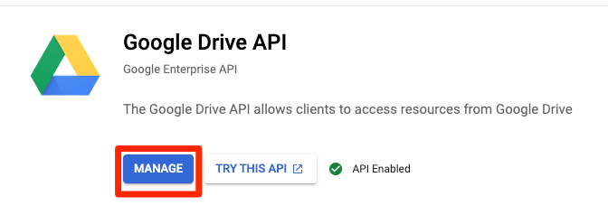
- From the leftside menu, choose “Drive UI Integration”
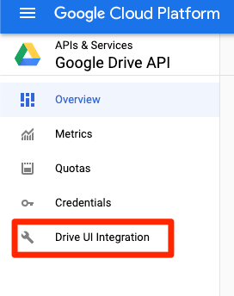
- Define basic values for the Drive Integration. Set ‘Application Name’ and ‘Short Description’ to “Share using SpecterX”.
The Application Name will be visible to the users in the files’ right-click menu under “Open with” in Google Drive.
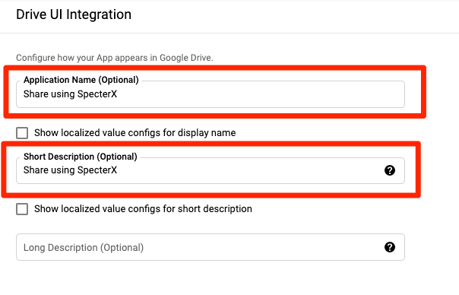
- For all icons, use this:
https://lh3.googleusercontent.com/-HNbWJF_GBkY/YV2tQvGSneI/AAAAAAAAA2E/8HyZ1qDN1GUA0h1Q8Q9arTt4u6s-lj6LgCLcBGAsYHQ/s400/specterx-icon.png
- Define Drive Integration -
  - Under “Open URL”, set this value -
https://[tenant-name].specterx.com/gdrive/share
  - Under “Default File Extensions” add these values -
pdf doc docx ppt pptx xls xlsx
  - Check the box for “Multiple file support”, and Shared drives support
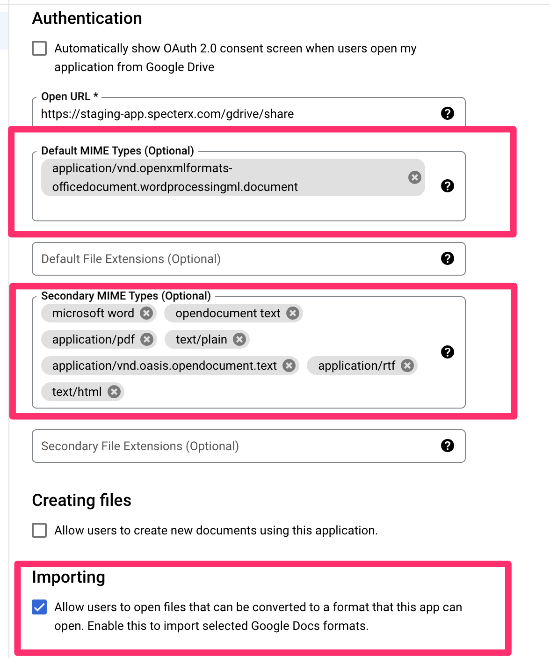

OAuth Consent
- On the right-side menu, click on the title “API & Service” to go back to the main APIs page.
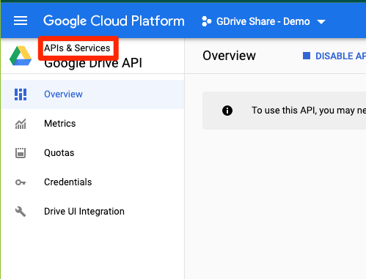
- Click “OAuth consent screen”
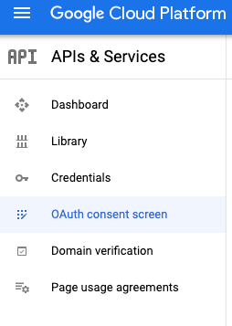
- Choose “External” and create “Create”
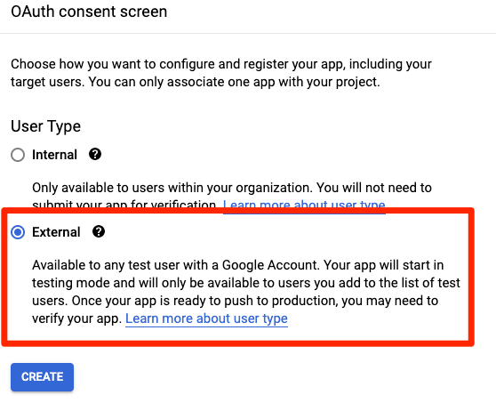
- 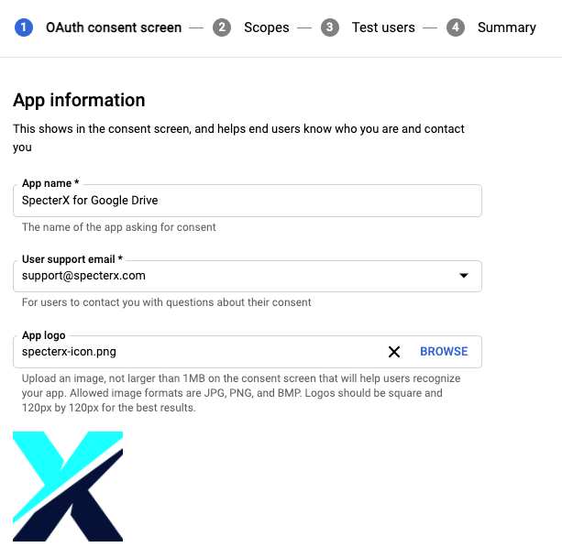
- 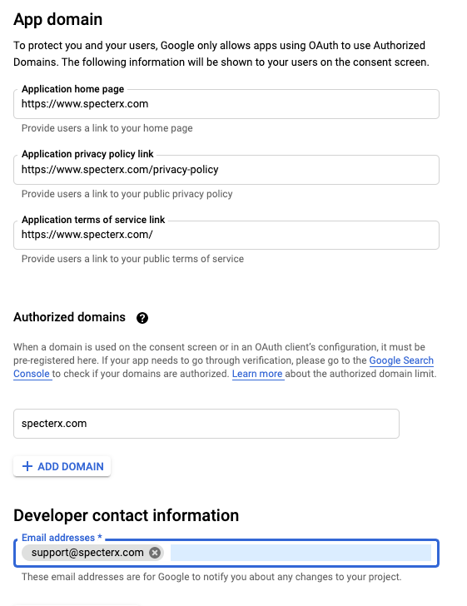
- 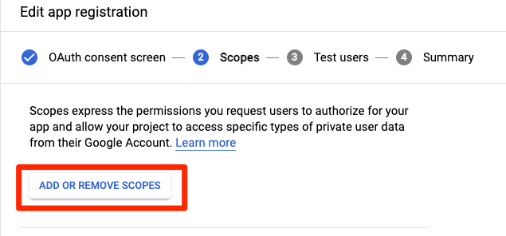
- https://www.googleapis.com/auth/drive.file, https://www.googleapis.com/auth/drive.install
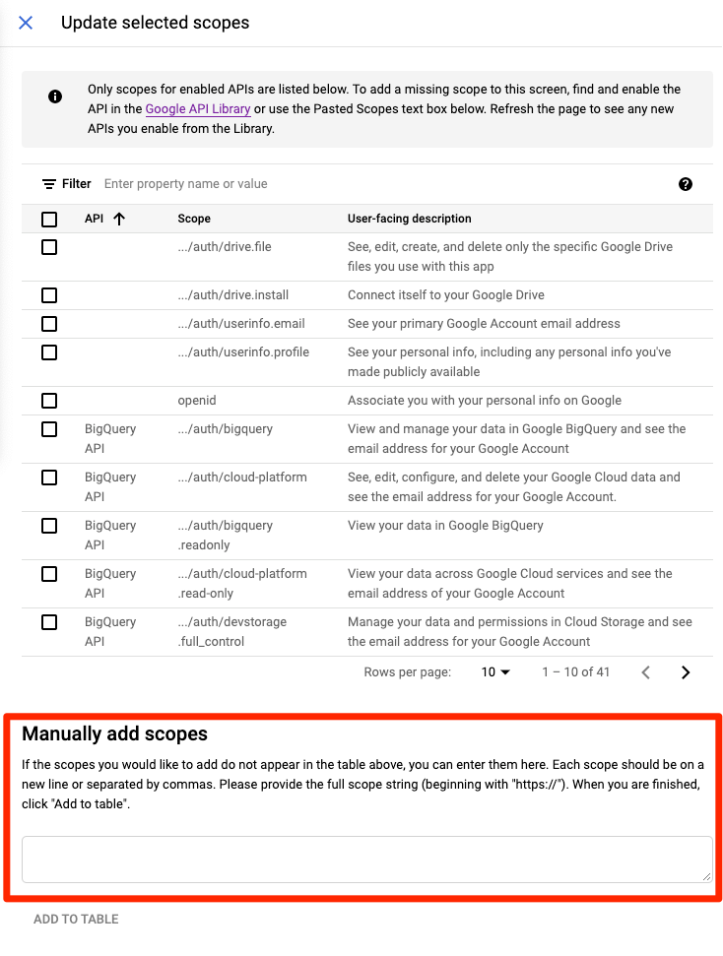
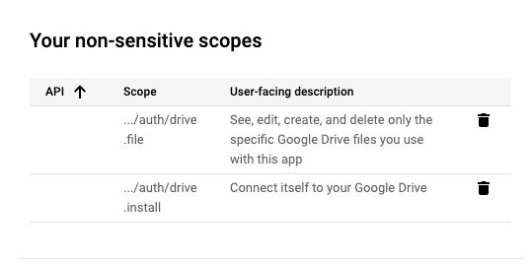

Credentials
- 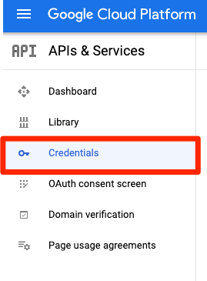
- 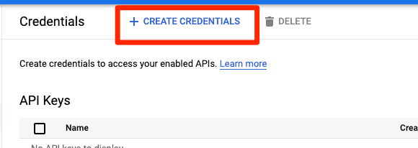
- 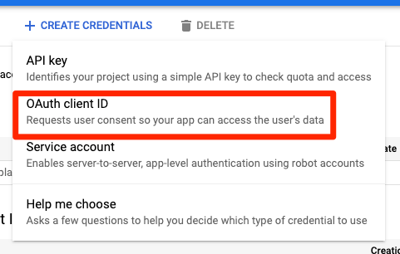
- Name it like: ‘SpecterX Web Client - Plarium’
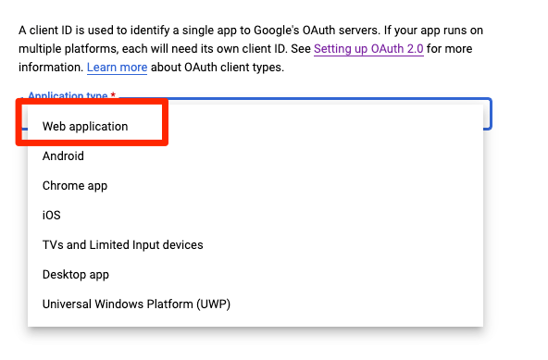
- 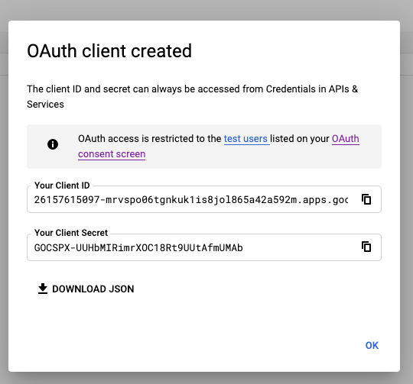
- Click “Download JSON” and save the file under the cloud_apps reportsioty in the gdrive_share_client_secrets folder. Rename it to match the other files’ standard.
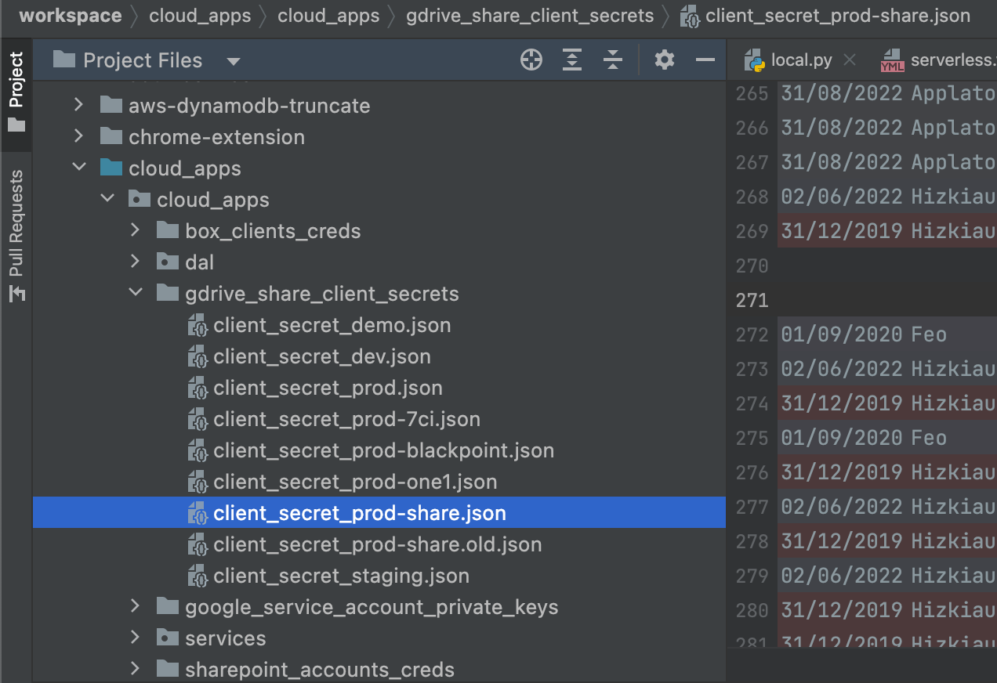
I think we don’t need to add it to: `auth-service\src\gdrive-share-client-secrets\` but if some problems occur think of adding it to there

- 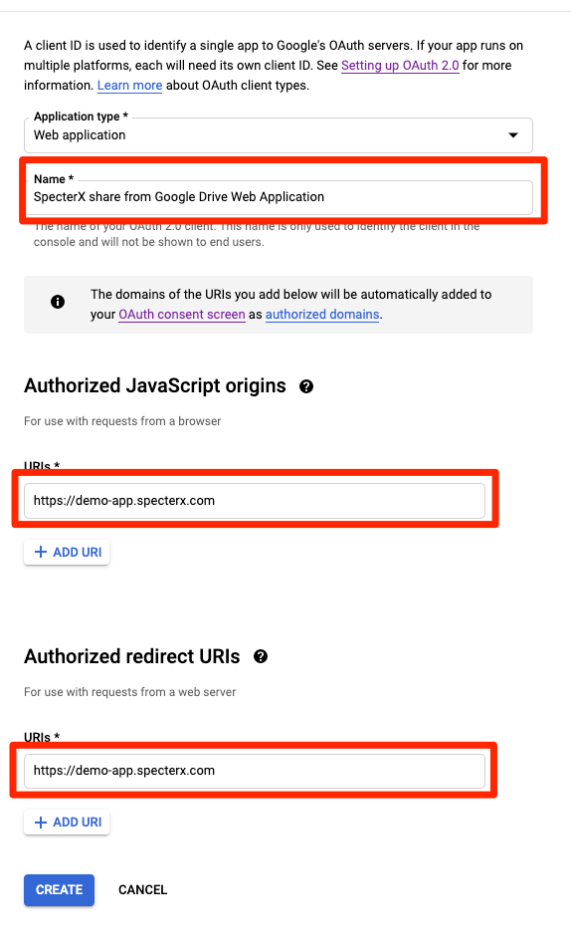

Note
Make sure all relevant feature flags are enabled.

Testing
To test that everything works, go back to the project’s “OAuth consent screen”.
The app should be in “Testing” status.

Don’t click on publish yet!

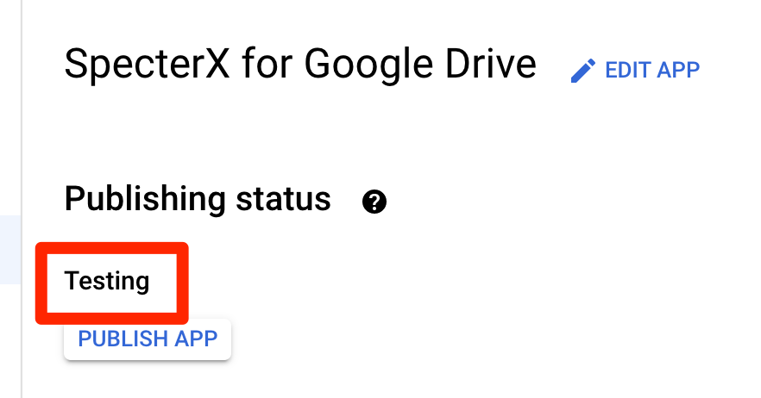

Under the test users section, add your user on SpecterX
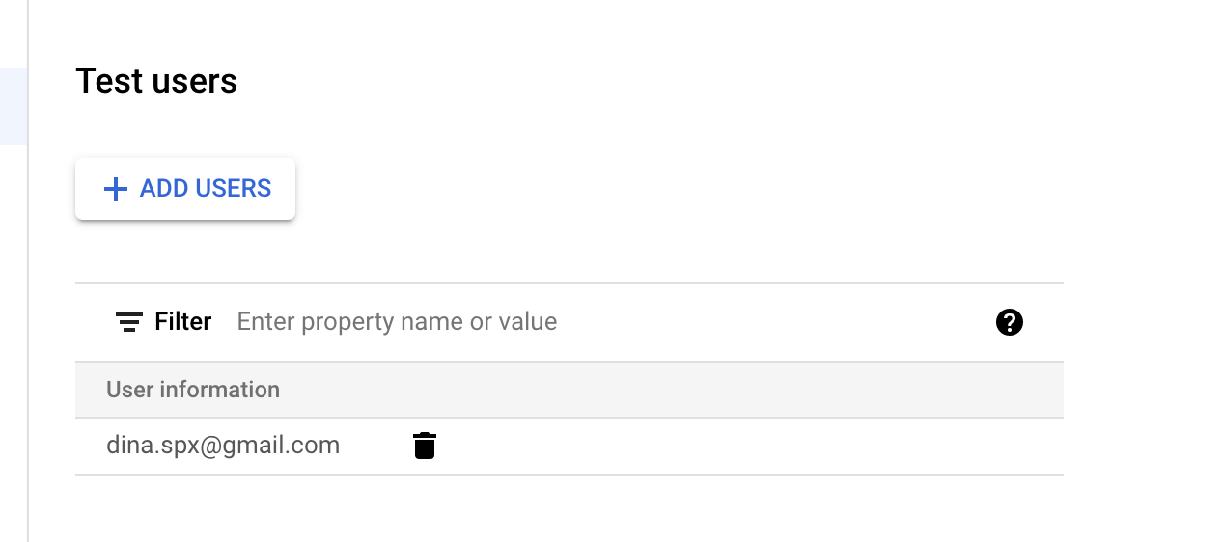

After doing that, go to the tenant you set this project for (tenant_name.specter.com) and connect to Google by clicking on the ‘profile picture’ on the top right.

If everything works, publish the app.

Google Docs Button Integration - Manual

Google Developer console

Create a new project
- In the Google Cloud Platform admin panel, create a new project
- Give it a name with this name convention:
GDrive SA - {customer_name}
(for example GDrive SA - REE)
- Enable APIs for the project (make sure the new project is selected at the top navigation bar:
  - Enable Gmail API
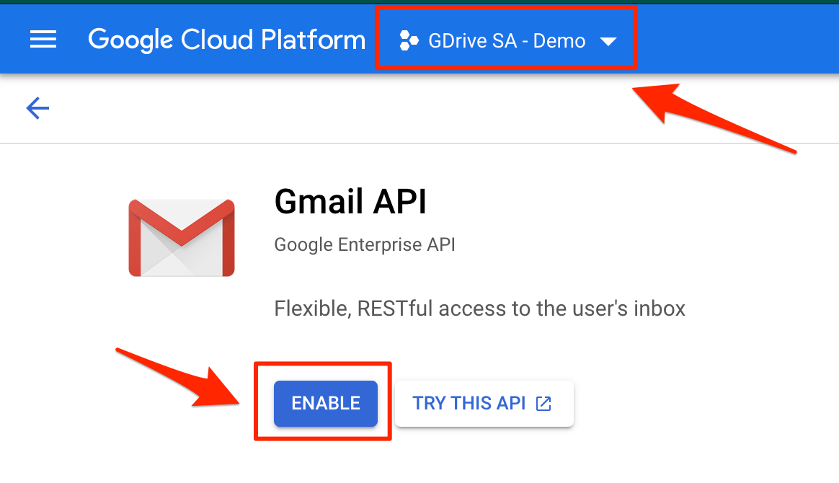
  - Enable Drive API (check the selected project again, it might change)
Make sure you select the newly created project:
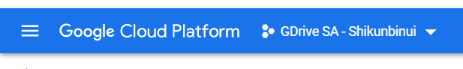
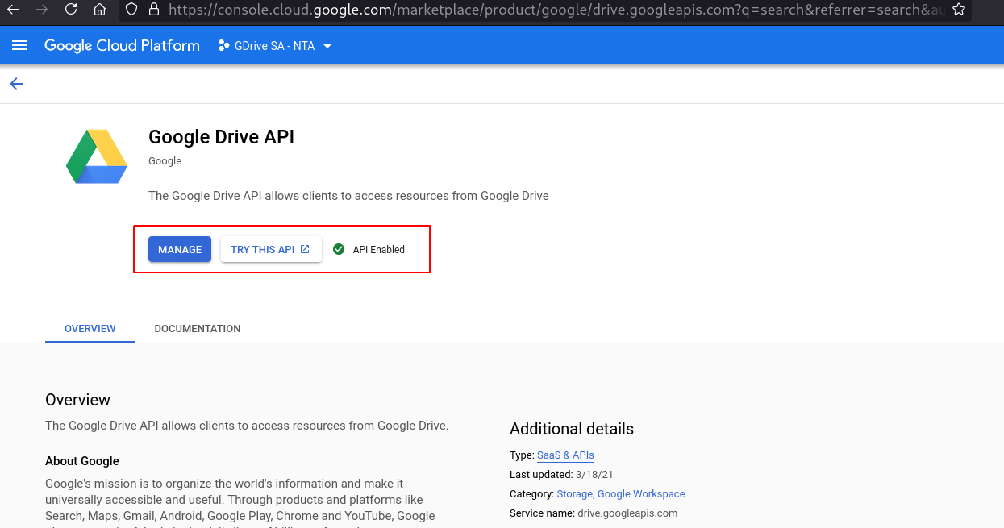

Create a topic
- This must be done under “Gdrive SA - Prod” project in Google Developers Console
here
- Go to Pub/Sub
- Create a new topic and name it - secure-share-mailbox-{ENV}
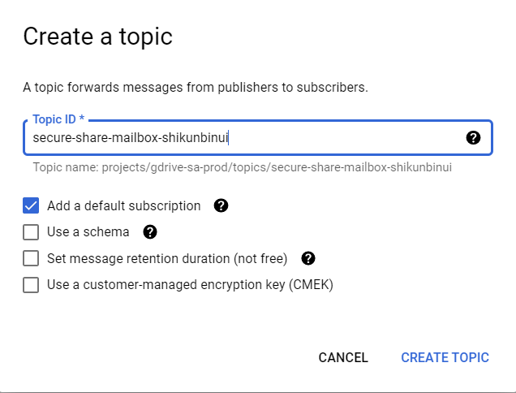

- Add gmail-api-push@system.gserviceaccount.com as a publisher under permissions
  - 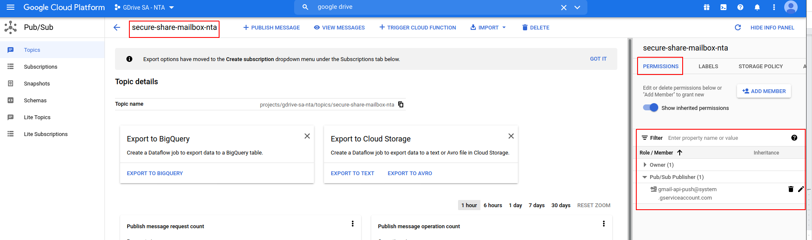
  - 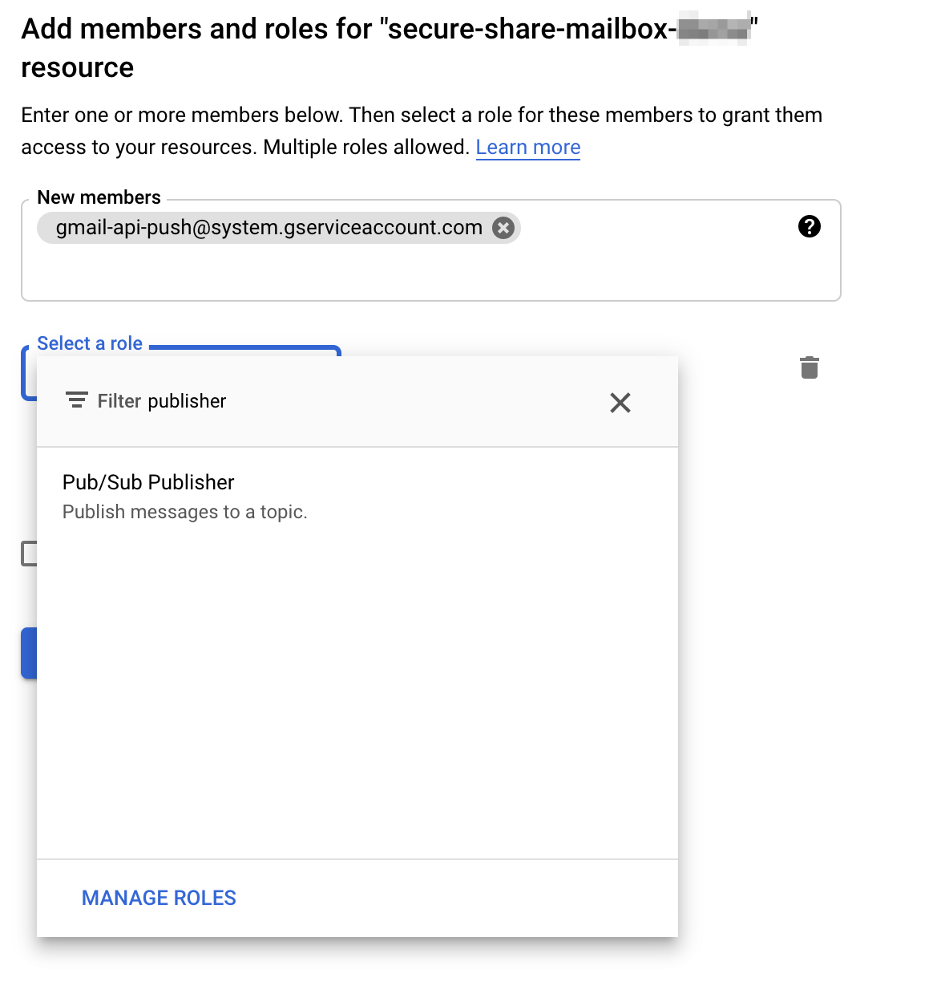

Create subscription
- Subscription id - secure-sharing-mailbox-{ENV}
- Select a cloud pub/sub topic - the topic from the previous step
- Delivery type - Push
  - Endpoint URL should be https://{cusomer}-api.specterx.com/access/googledrive/parse_sharing_request
- Subscription expiration - Never
- Acknowledgment deadline - 30s
- Retry policy - retry after exponential backoff delay (default values)
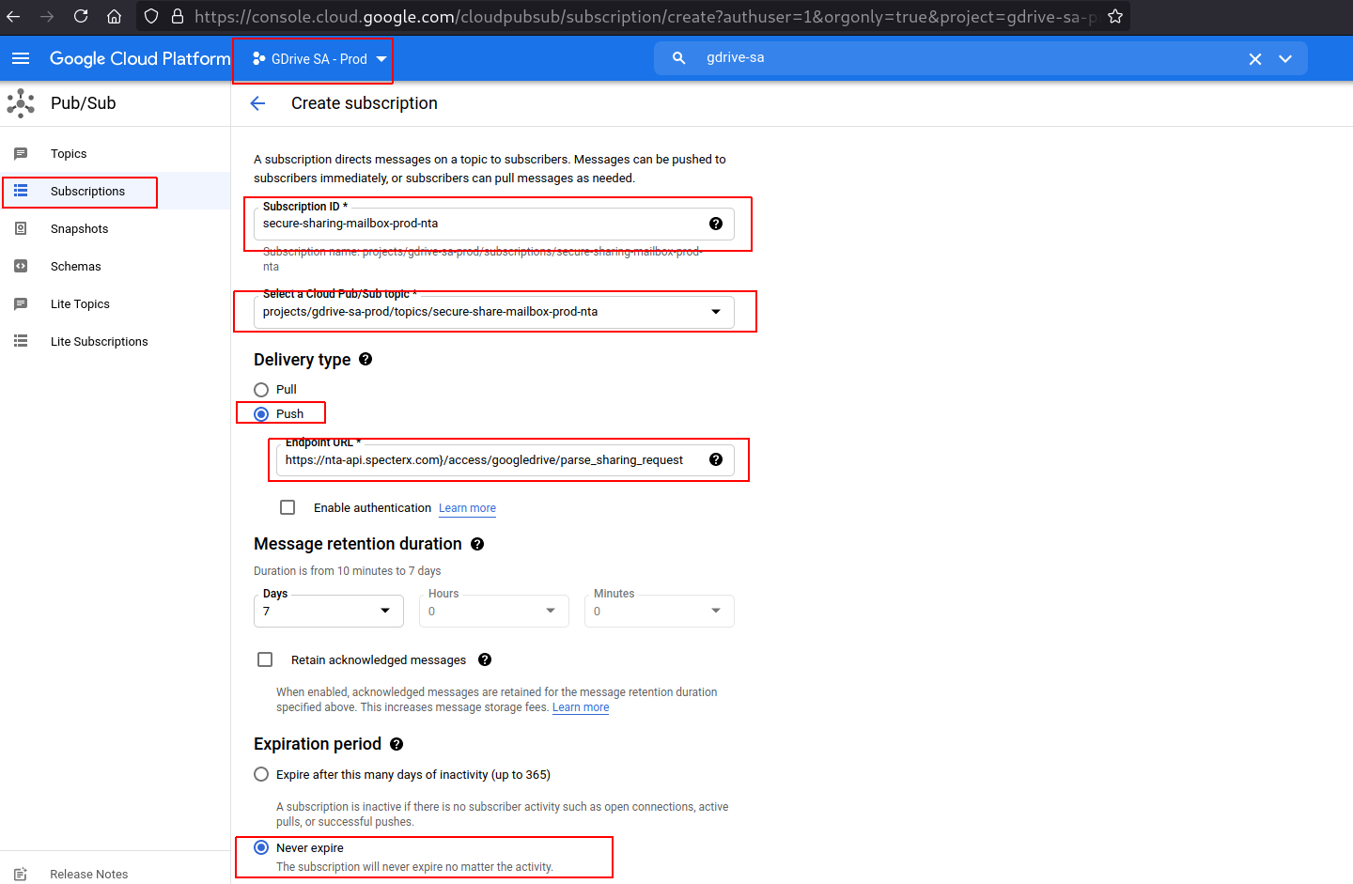

Create a service account
(Documentation reference: https://cloud.google.com/iam/docs/creating-managing-service-accounts )
- Go to the Service accounts page
- Select customer’s newly created project
- Service account name - google-drive-service-account
  - Create with default values

Create OAuth consent
- Go to OAuth consent screen panel
- Choose “Internal” and click Create
- Name: Google Drive Service Account - {Customer name}
- Use “support@specterx.com” as developer email address and user support email.
- Click ‘Next’
- Add scope - https://www.googleapis.com/auth/gmail.readonly
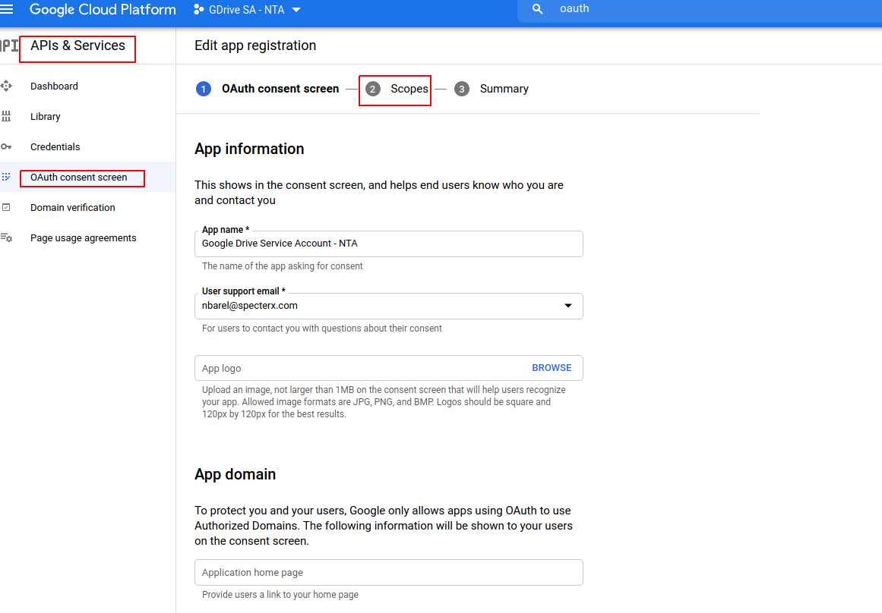
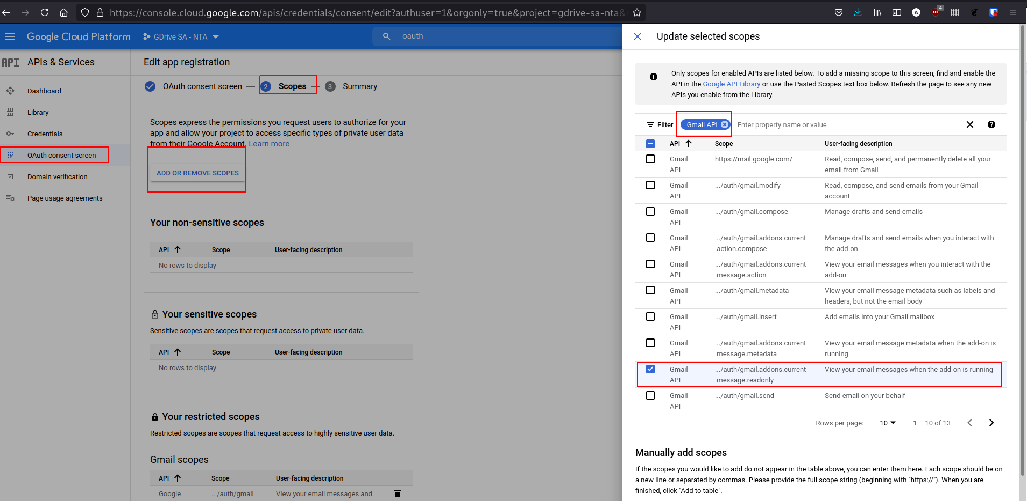

Save and continue!
- Go back to service account settings and enable Domain-Wide Delegation
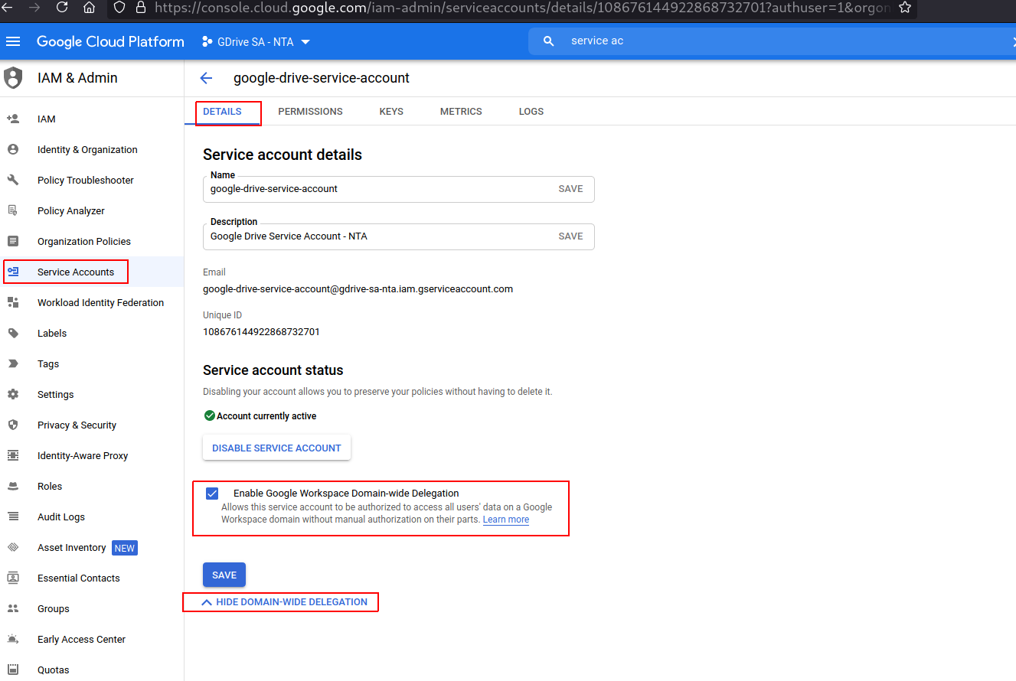
Above deprecated

- Create a key in JSON format and save it for later
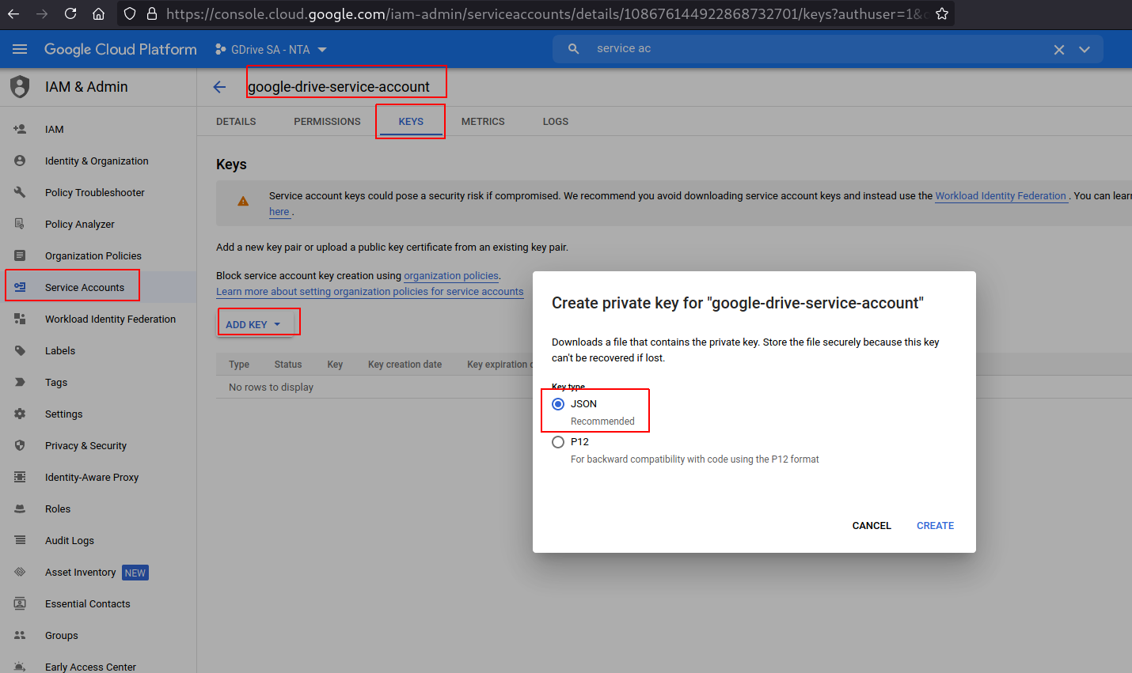
- Copy service account unique id for later

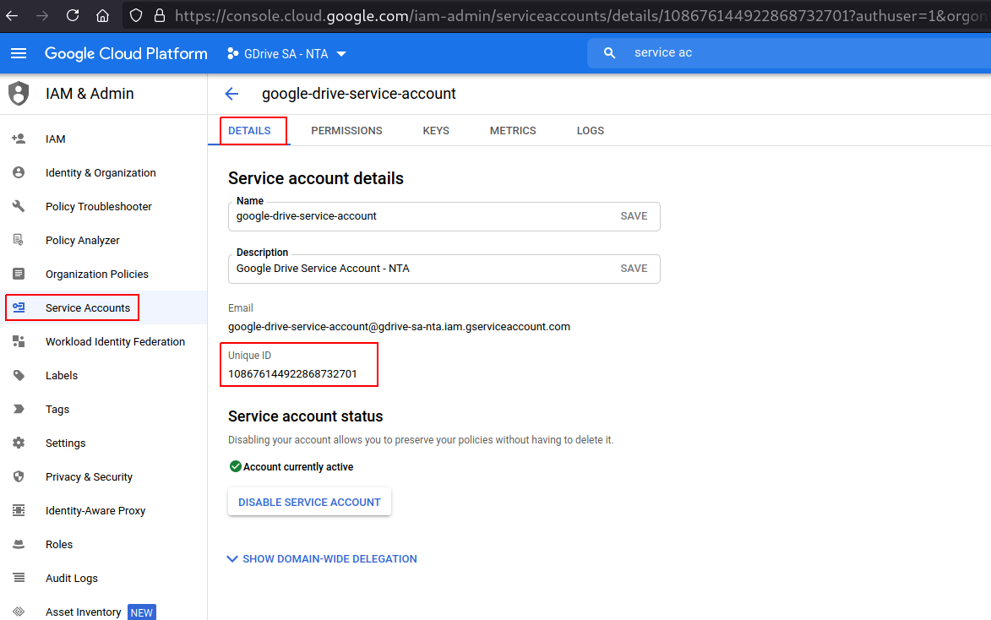

Create OAuth 2.0 Client ID
You will need this to update Google App ID in web-client (as per New Tenant provisioning document).

- This must be done from “Gdrive SA - {customer}” project in Google Developers Console
- Browse to “APIs & Services” -> Credentials
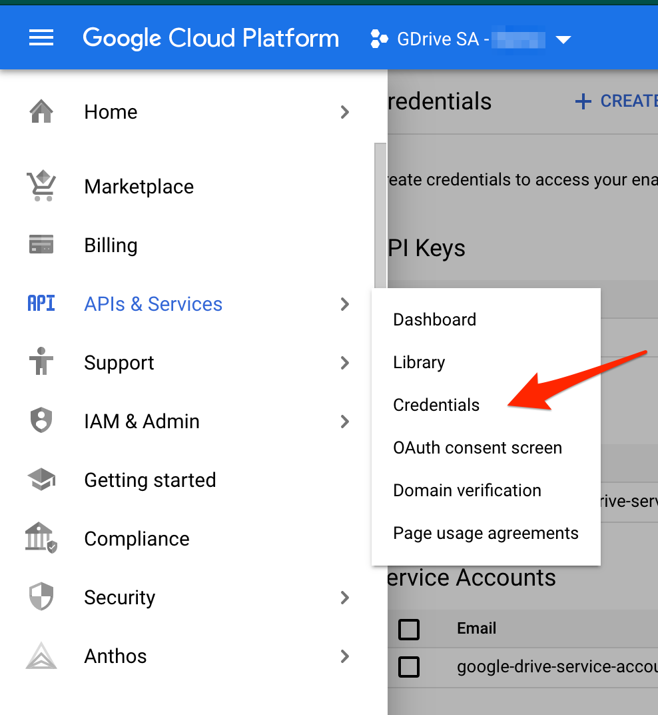
- Click on “+ Create credentials” and selec “OAuth client ID”
  - Application type: Web application
  - Name: “SpecterX Web Client - {customer}”
  - Add a new “Authorized JavaScript origin”
    - https://{custromer}.specterx.com
  - Add a new “Authorized redirect URI”
    - https://{custromer}.specterx.com
    - https://{customer}.specterx.com/gdrive/share
    - https://{customer}.specterx.com/signin
    - https://{customer}.specterx.com/shared-file
After filling in the details, it should look like this:
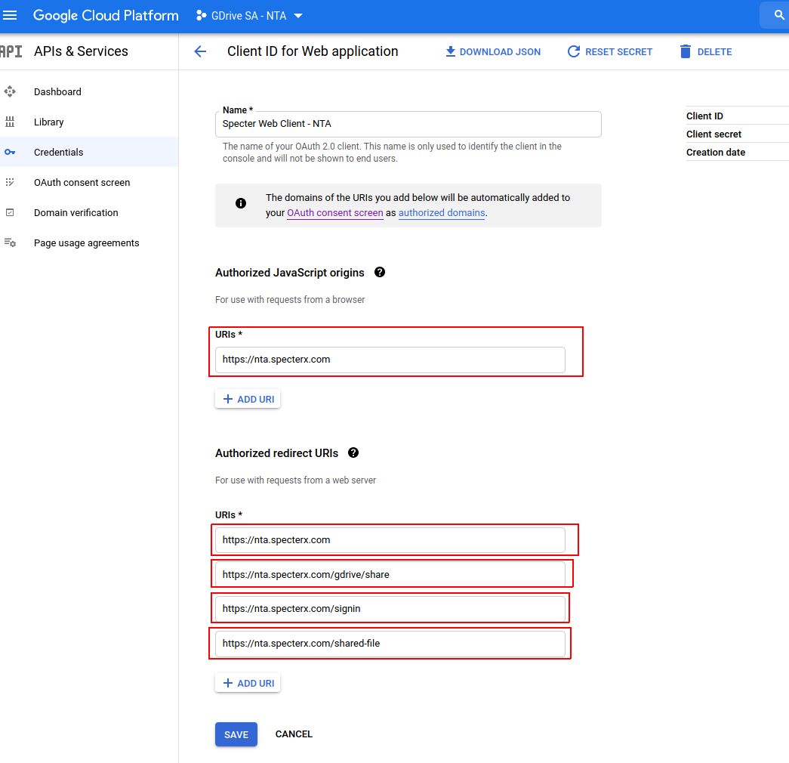
- Click “create”. You should see “SpecterX Web Client - {customer}” under “OAuth 2.0 Client IDs” now. Click it
- Copy and save the “Client ID” field value - this is the value for “APP_ID” attribute under “google” in web-client/src/config/env.js

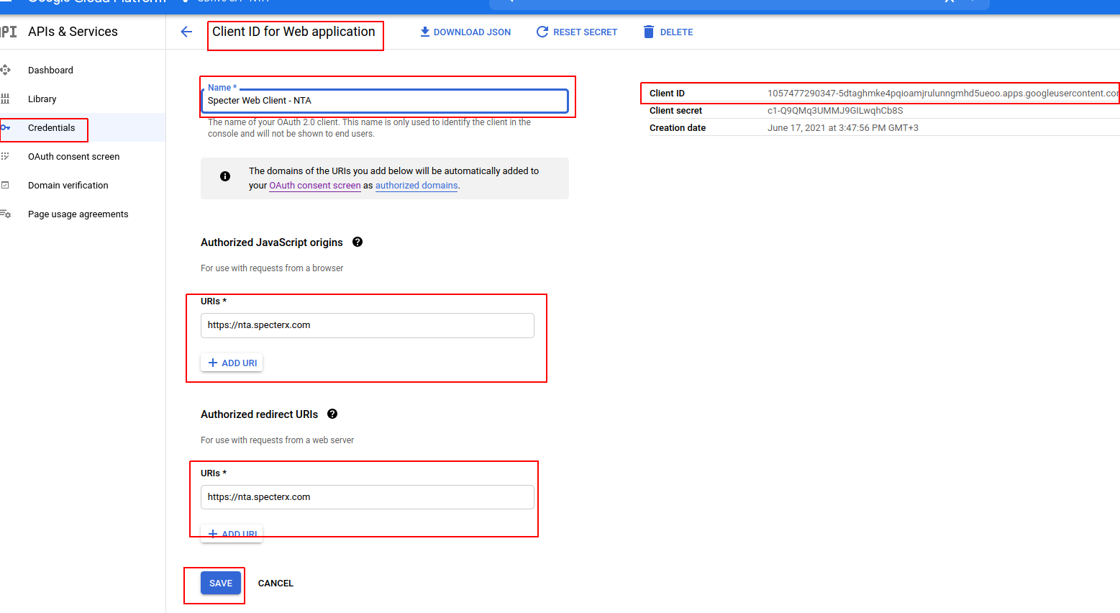

GSuite

Add service account scopes
- Go to GSuit Admin Console
- Gsuite > security > API control > Manage domain-wide delegation > add new
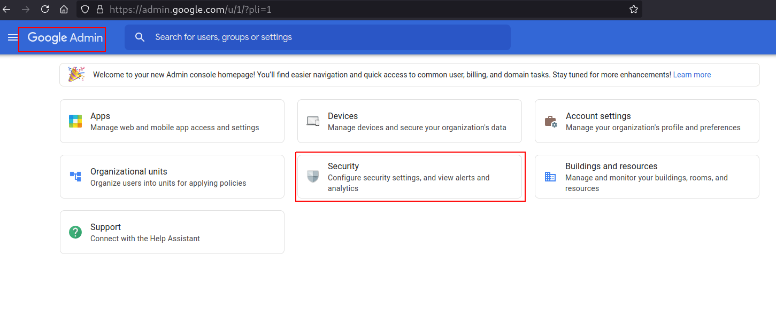
- Client ID - the service account unique id from the previous step
- Scope:
  - https://www.googleapis.com/auth/drive
  - https://www.googleapis.com/auth/drive.file
  - https://www.googleapis.com/auth/gmail.readonly

Create GSuite user
- Go to Directory -> Users
- Click ’Add new user’
- Name
- {env}-secure-sharing@specterx.com
  - Put it under Services Accounts organization
  - Save password

Repositories

common_modules
- Take the JSON file we downloaded earlier and put it in common_modules repo: cloud_apps/google_service_account_private_keys/gdrive-sa-{env}.json
i.e - gdrive-sa-prod-ree
- Commit and push

Update configuration repo
- google_mediation_account - the email address of the GSuite user
- google_share_request_topic - the topic name from Google Developer console

Deploy configuration repo
Deploy download/access repo

